PROJECT DEVELOPMENT - DELIVERY OF SPRINT 3

|  |  |
| --- | --- |
| Date: | 12 November 2022 |
| Team ID: | PNT2022TMID48076 |
| Name: | Real-Time River Water Quality Monitoring and Control System |

**Ibm Watson connected with node red:**

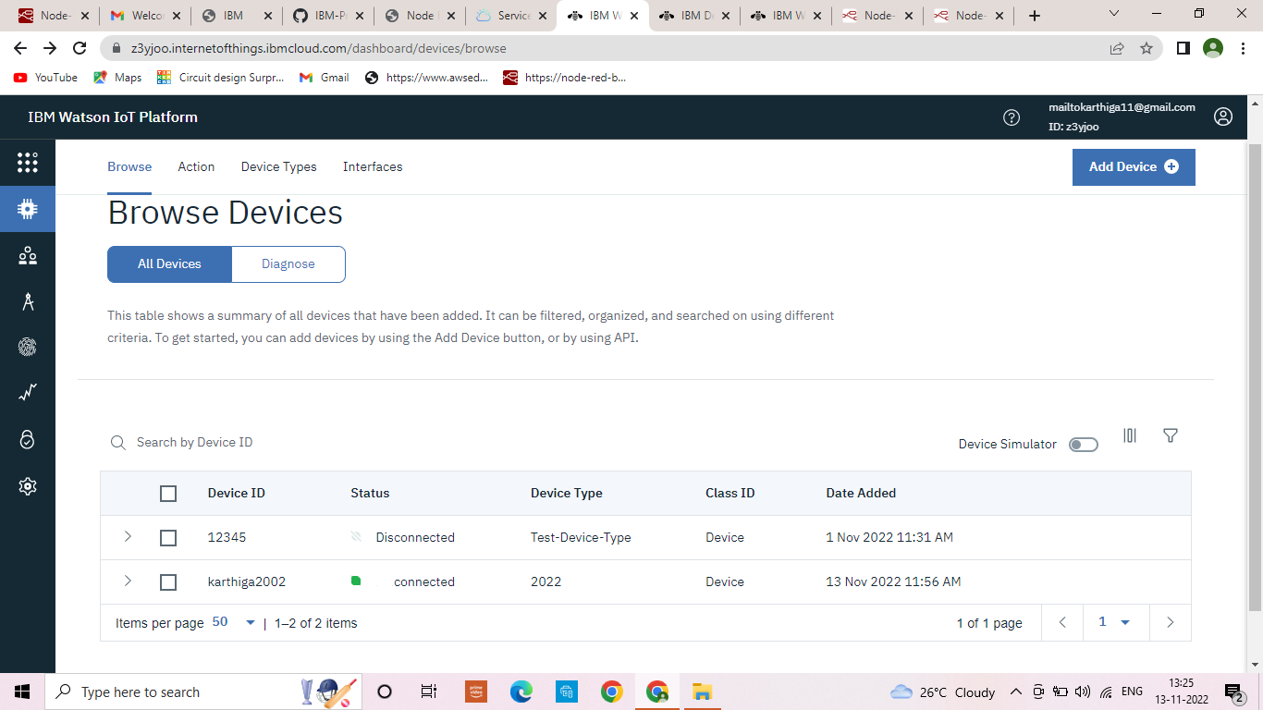

**Node red dashboard connection:**

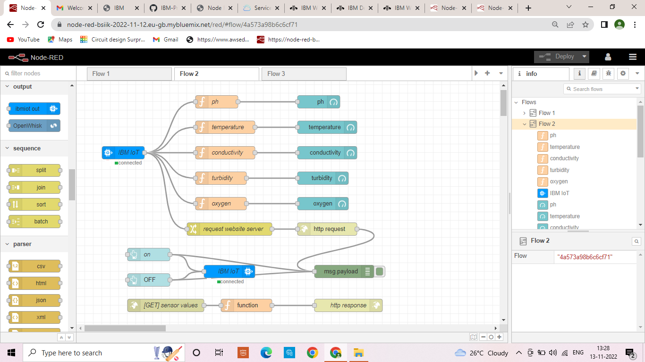

**Notification to Ibm Watson:**

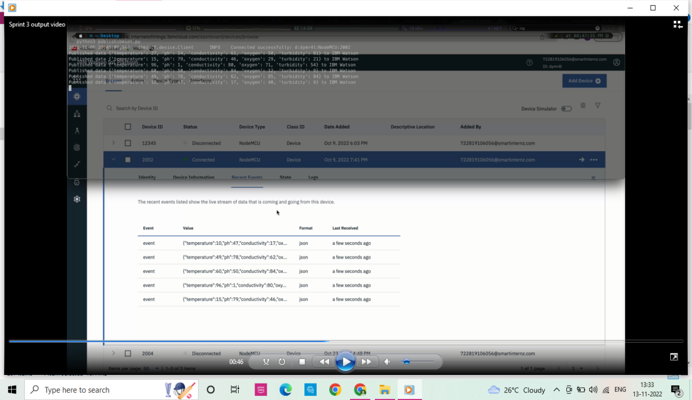

**Output of dashboard connection in node red:**



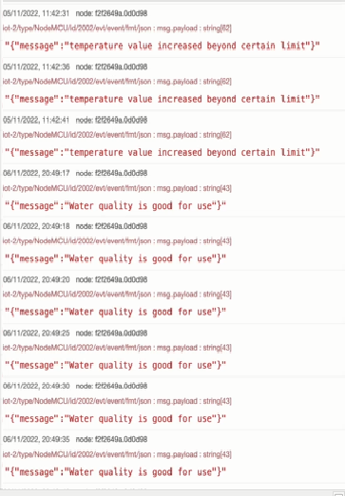

**Output of UI web application:**

